8.In the below network assume that TCP is used and also ,A has only 3 packets, with the size of 4Mbyte,to send to B, and these packets are sent into the network in 4ms time intervals and also RTT is estimated as the ack for each of these packets gets to the sender.



The router structure is as below:

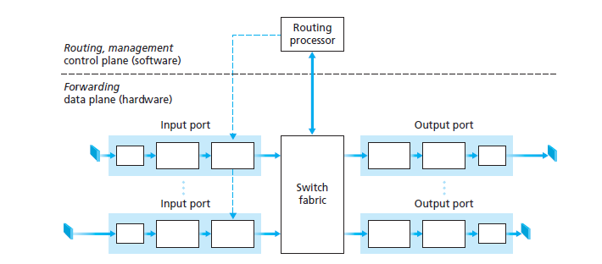

Transmission rate=0.5Mbit/sec

Transmission rate=1Mbit/sec

The propagation delay on all the links is zero and the capacity of the links equals to 50Gbit/sec and also processing delay equals to 4ms and the buffer size equals to 12Mbyte,and also assume that each packet transmitted from input port to out port when it gets to the  head of the queue with no delay the transmission rates are as below:

Sender transmission rate=1Mbit/sec

receiver transmission rate=1Mbit/sec

router output port transmission rate=0.5Mbit/sec

calculate time out interval regarding to TCP after receiving the ack for each packet , for the below scenarios:

a)none of the bits of the packets gets corrupted.(the time out interval for the first packet equals to 1ms)

b)one of the bits of the third packet gets corrupted so the sender sends it again, and this time it gets to the receiver with no corruption.

Hint: You may want to make use below formulas:



 β=0.25